

|  |  |  |  |  |  |  |  |  |
| --- | --- | --- | --- | --- | --- | --- | --- | --- |
|  | | | | | | | | |
|  | | Object Detection, Semantic Segmentation, and Instance Segmentation | | | | |  | |
|  |  | | | | | | |  |
|  | | | |  |  | | | |
|  | | | | Utsav Anantbhat |  | | | |
|  | | | | 1/31/2023 |  | | | |
|  | | |  | | |  | | |

Part 1:

* Configs (original):

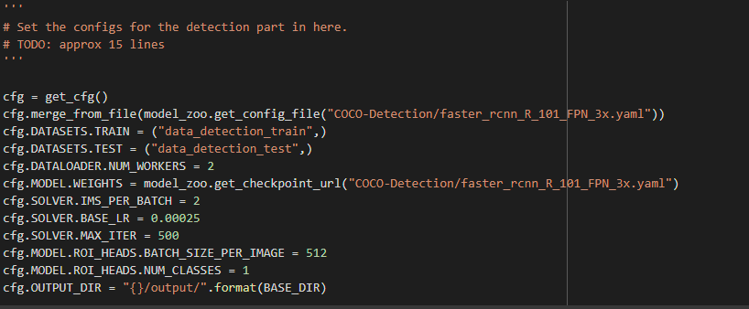

* Factors which helped improve performance:
* Training Loss and Accuracy:

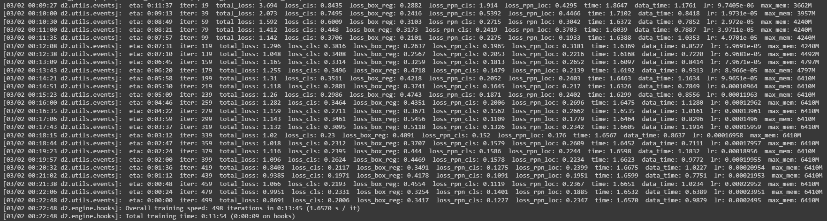Total loss: 0.8691

* Visualization:

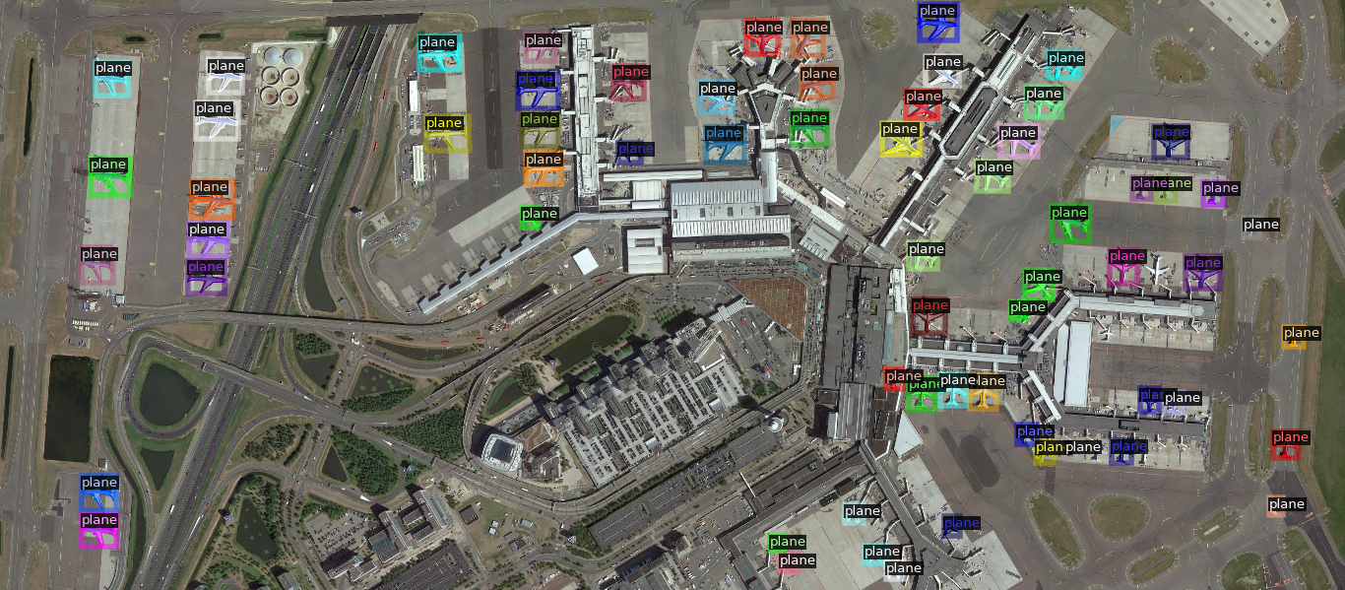

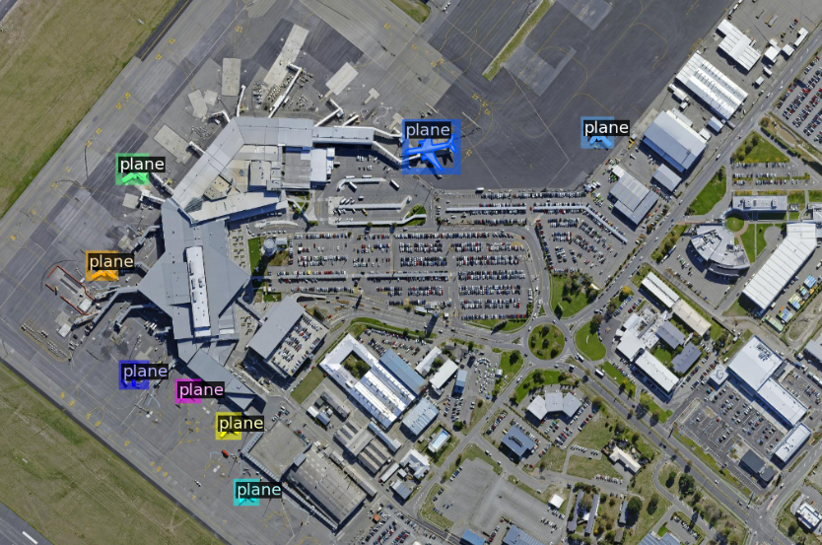

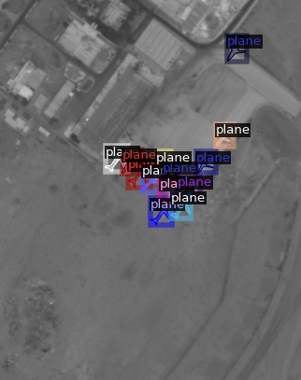

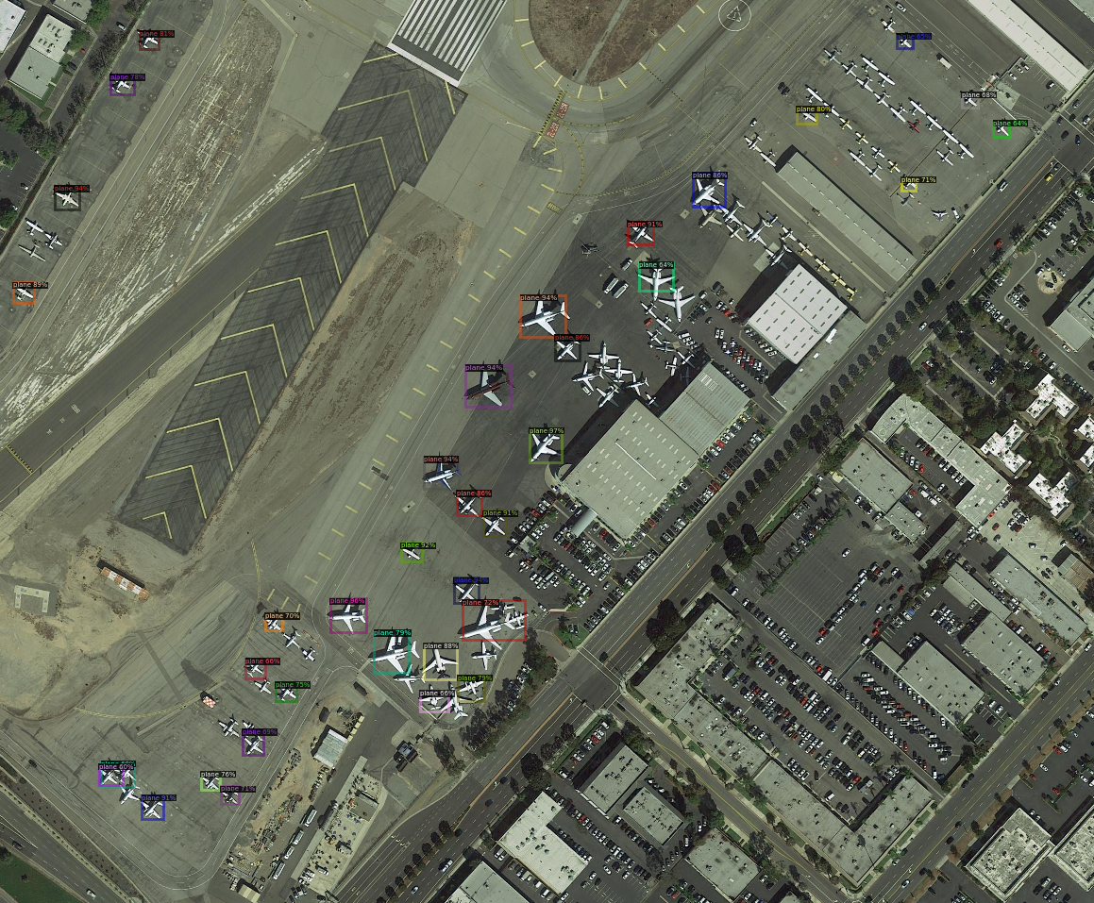

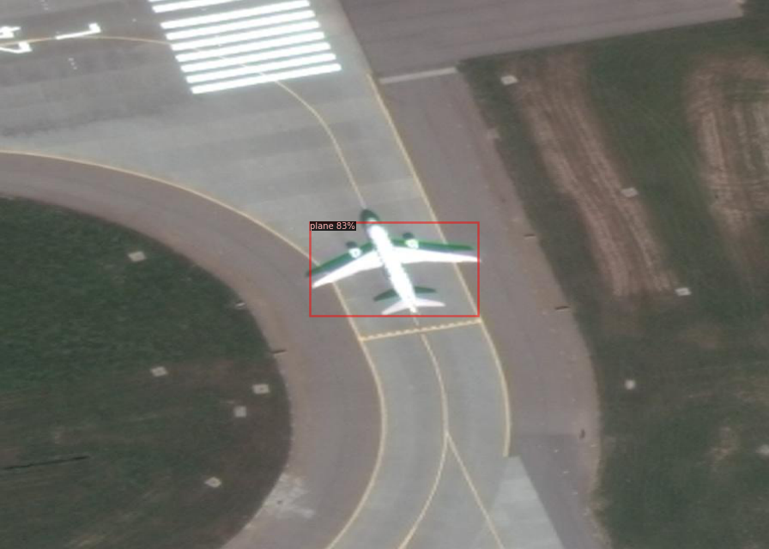

* Ablation Study:

Faster R-CNN vs Mask R-CNN:

* Faster R-CNN has 2 outputs for each object (class label and bbox), Mask R-CNN has a third output: object mask.
* Mask R-CNN easier to train and theoretically more efficient than Faster R-CNN
* Mask R-CNN has less overhead compared to Faster R-CNN.

Source[: https://viso.ai/deep-learning/mask-r-cnn/#:~:text=While%20Faster%20R%2DCNN%20has,spatial%20layout%20of%20an%20object.](:%20https:/viso.ai/deep-learning/mask-r-cnn/%23:~:text=While%20Faster%20R%2DCNN%20has,spatial%20layout%20of%20an%20object.)

Part 2:

* Hyperparameter settings:

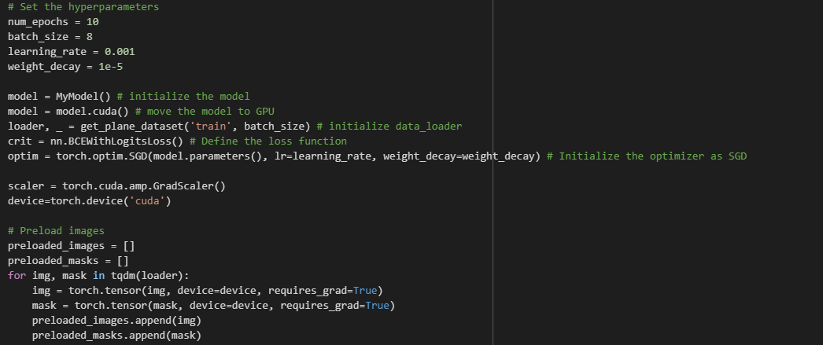

batch_size = 8, learning_rate = 0.001, num_epochs = 10, optimizer = SGD

* Improved Network:

class conv(nn.Module):

    def __init__(self, in_ch, out_ch, activation=True):

        super(conv, self).__init__()

        if activation:

            self.layer = nn.Sequential(

                nn.Conv2d(in_ch, out_ch, 3, padding=1),

                nn.BatchNorm2d(out_ch),

                nn.ReLU(inplace=True)

            )

        else:

            self.layer = nn.Conv2d(in_ch, out_ch, 3, padding=1)

    def forward(self, x):

        x = self.layer(x)

        return x

class down(nn.Module):

    def __init__(self, in_ch, out_ch):

        super(down, self).__init__()

        self.layer = nn.Sequential(

            conv(in_ch, out_ch),

            nn.MaxPool2d(2)

        )

    def forward(self, x):

        x = self.layer(x)

        return x

class up(nn.Module):

    def __init__(self, in_ch, out_ch, bilinear=True):

        super(up, self).__init__()

        # use bilinear upsampling if specified, else use transpose convolution

        if bilinear:

            self.up = nn.Upsample(scale_factor=2, mode='bilinear', align_corners=True)

        else:

            self.up = nn.ConvTranspose2d(in_ch, in_ch // 2, 2, stride=2)

        self.conv = conv(in_ch, out_ch)

    def forward(self, x1, x2=None):

        y = self.up(x1)

        if x2 is not None:

            y = torch.cat([y, x2], dim=1)

        y = self.conv(y)

        return y

class MyModel(nn.Module):

    def __init__(self):

        super(MyModel, self).__init__()

        # Encoder

        self.input_conv = conv(3, 16)

        self.down1 = down(16, 32)

        self.down2 = down(32, 64)

        self.down3 = down(64, 128)

        # Decoder

        self.up3 = up(128, 64)

        self.up2 = up(64, 32)

        self.up1 = up(32, 16)

        self.output_conv = nn.Conv2d(16, 1, 1)

    def forward(self, input):

        x1 = self.input_conv(input)

        x2 = self.down1(x1)

        x3 = self.down2(x2)

        x4 = self.down3(x3)

        y3 = self.up3(x4, x3)

        y2 = self.up2(y3, x2)

        y1 = self.up1(y2, x1)

        output = self.output_conv(y1)

        return output

'''

Improvements made:

> Increased # of channels

> Add skip connections

> Change upsampling method

'''

Improvements:

* Increasing the number of channels in the convolutional layers can allow for more complex features to be implemented.
* Skip connections can be added between the encoder and decoder to preserve spatial info and improve performance. Achieved by concatenating the output of upsampling layer with corresponding layer from encoder.
* Original upsampling method was a transpose convolution which can produce artifacts. Better to use bilinear upsampling which preserves spatial info well.
* Training and Loss:

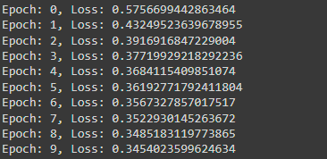

* Final Mean IoU:

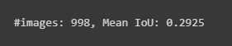

* Visualization:

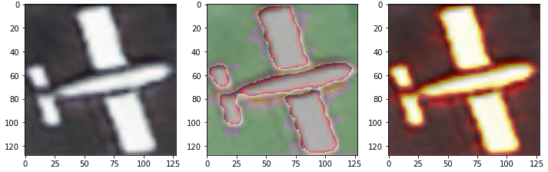

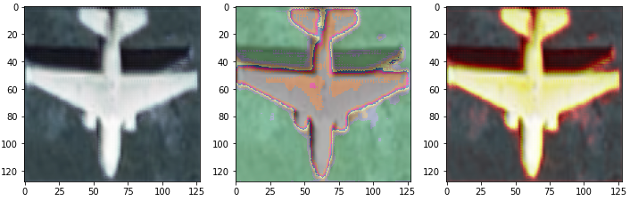

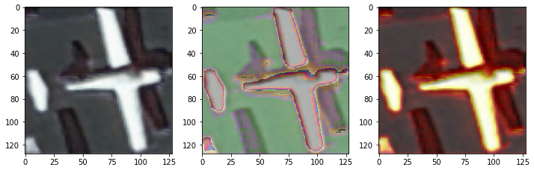

Part 3:

Implementation incomplete; unable to upload CSV file.

Part 4:

* Evaluation and Visualization:

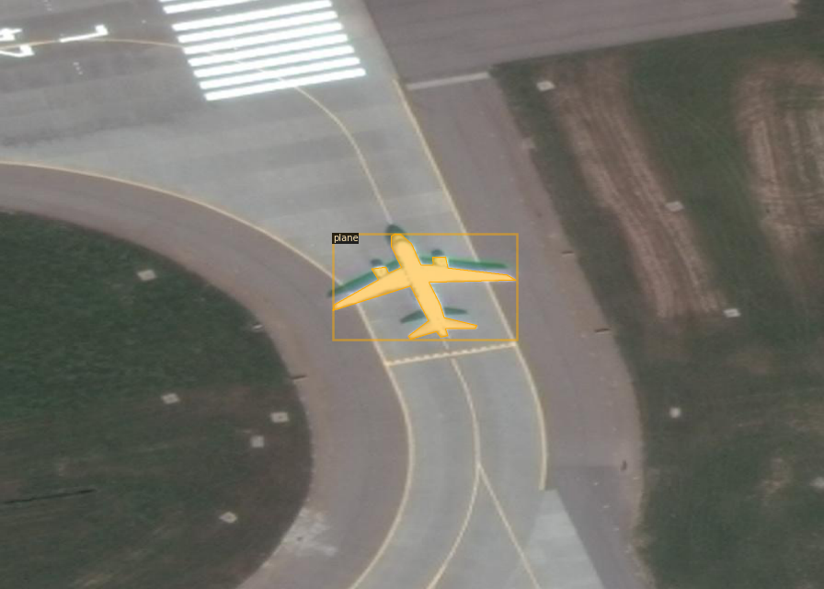

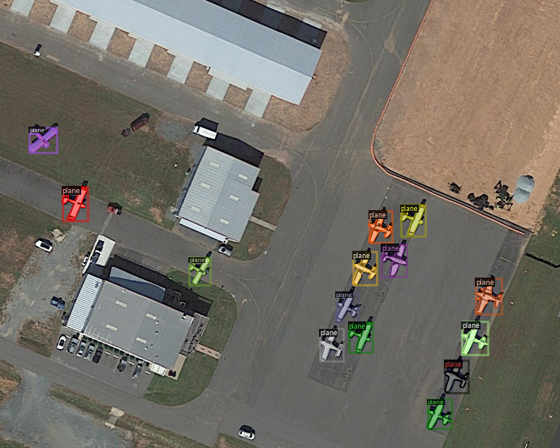

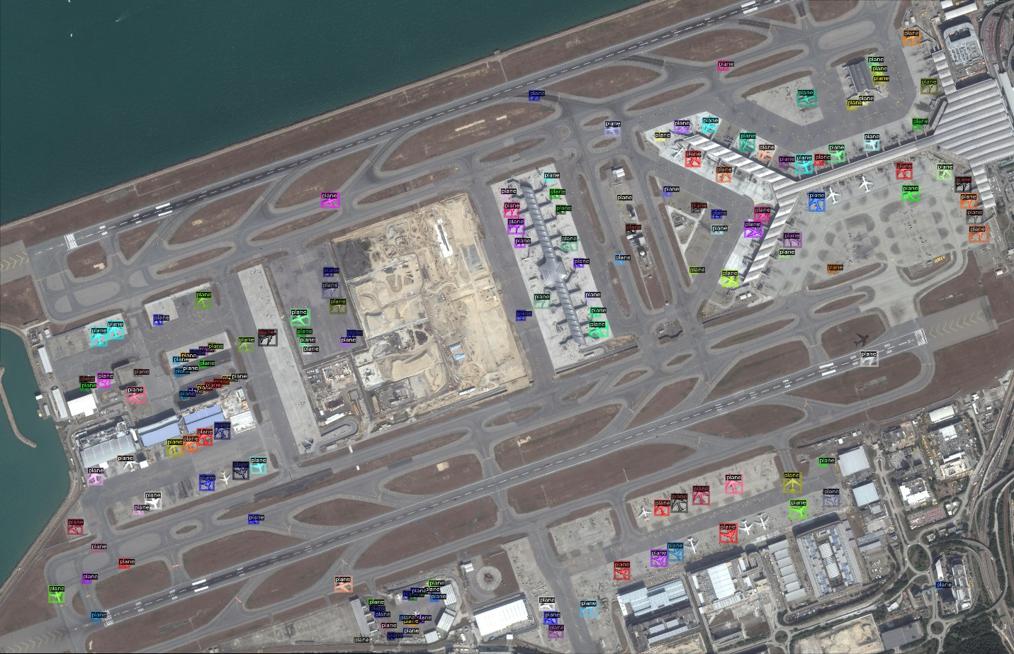

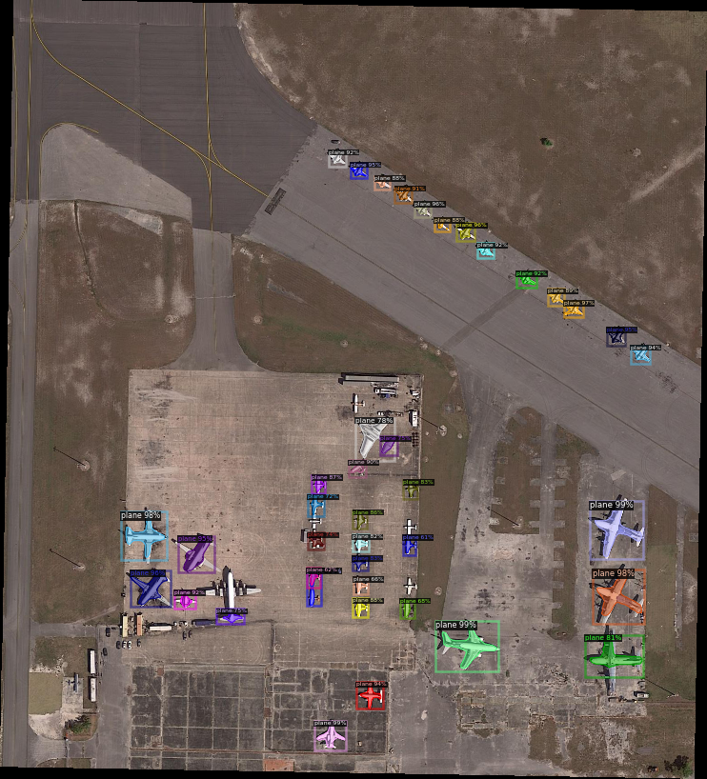

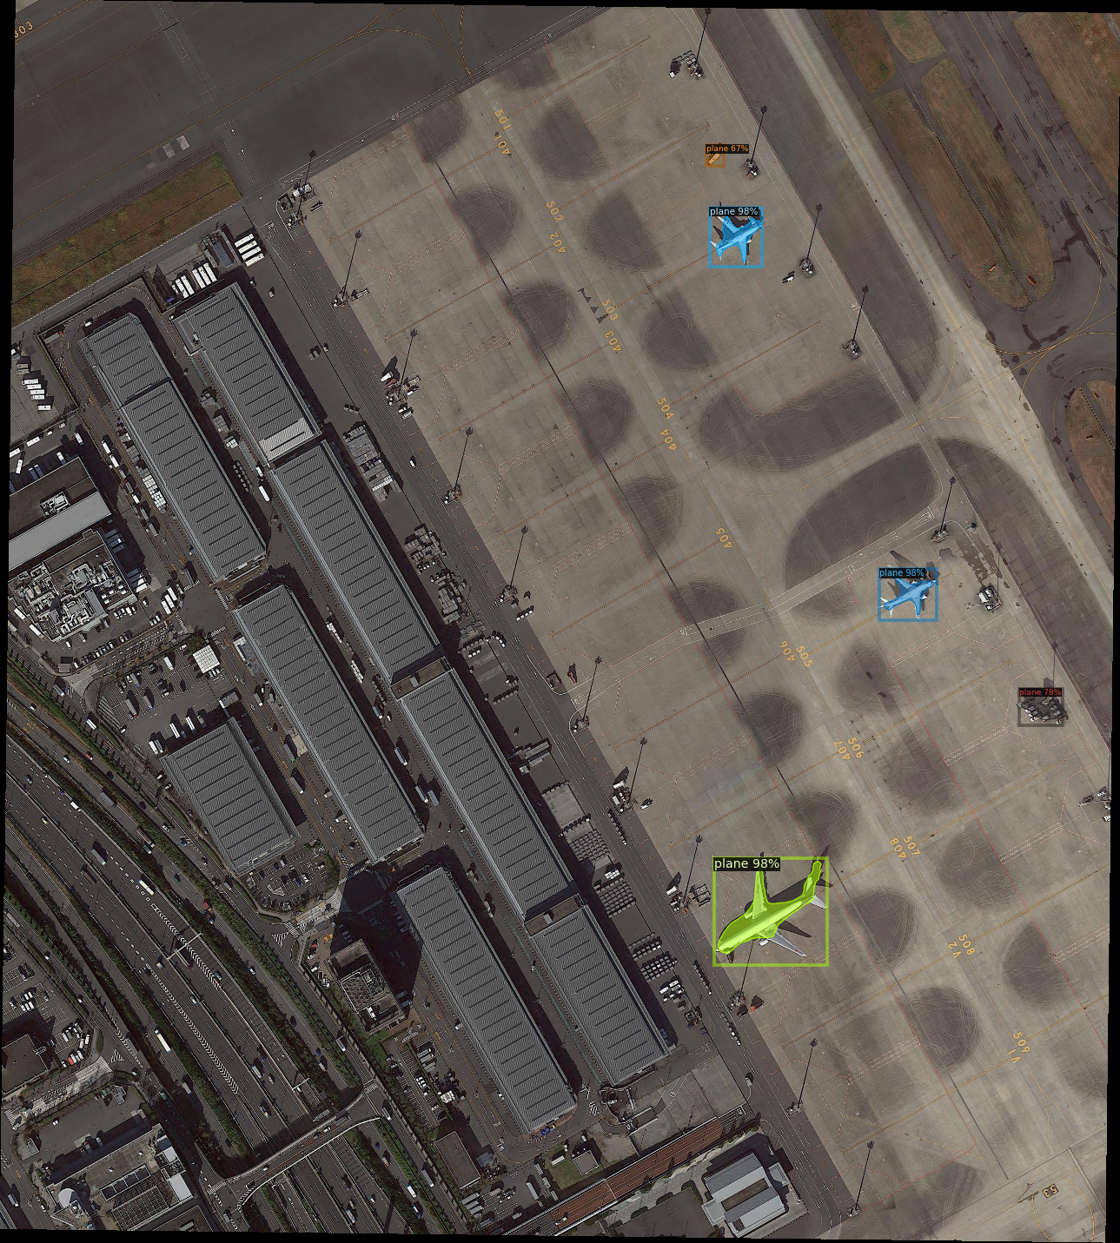

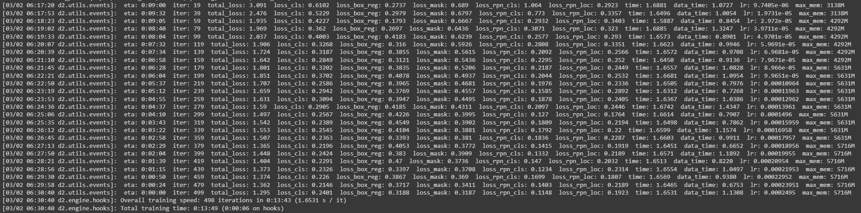

Total loss: 1.295

The loss was greater using “mask_rcnn_R_50_FPN_3x.yaml” compared to “faster_rcnn_R_101_FPN_3x.yml” using the same configurations. The time taken for the training was more or less the same.